Montgomery County Traffic​ Safety Analysis
Jhonathan Urquilla
Data 205 Capstone Project
Professor Perine
May, 13 2026Introduction / Overview
Traffic safety is an important public safety issue that affects drivers, pedestrians, and cyclists every day. Crashes and unsafe driving behaviors can lead to injuries, fatalities, property damage, and increased risks for everyone using roadways. Understanding patterns related to traffic activity and roadway incidents can help provide insight into high risk conditions and overall traffic safety concerns.
The purpose of this project was to analyze traffic crashes, non-motorist crashes involving pedestrians and cyclists, and traffic violations in Montgomery County. Instead of focusing on only one dataset independently, this project combined multiple datasets together to identify broader patterns related to roadway safety, crash activity, and traffic behavior.
The project also demonstrates how data science and visualization techniques can be used to analyze real world public safety issues and communicate trends more clearly through graphs, spatial analysis, and comparative visualizations.Research Question
The primary research question for this project was:
What patterns and relationships exist between traffic crashes, non-motorist incidents, and traffic violations in Montgomery County from 2022 to the present?
Additional questions explored throughout the analysis included:
- Do crashes, violations, and non-motorist incidents follow similar time based trends?
- Are there specific months or time periods with increased roadway activity?
- Where are crashes and violations geographically concentrated?
- What trends exist regarding non-motorist injury severity and fault involvement?
Data Sources
The project used datasets obtained from Data Montgomery. The original collection system for the datasets is the Maryland State Police Automated Crash Reporting System (ACRS). The reports are submitted by agencies including Montgomery County Police, Gaithersburg Police, Rockville Police, and the Maryland National Capital Park Police.
Three primary datasets were used throughout the project:
- Traffic crash reports
- Non-motorist crash reports involving pedestrians and cyclists
- Traffic violation reports
The datasets included information such as crash severity, locations, dates, times, weather conditions, driver behavior, and violation details. Some records may contain preliminary or unverified information, which is an important limitation when interpreting the results, especially if they are subjected to change upon further investigation.Methodology
Several tools and methods were used throughout the project. R Studio was used for data cleaning, preprocessing, statistical summaries, and analysis. Tableau Public was used to create GIS heat maps and visualizations. GitHub was used to organize project files and code throughout the project
Before analysis could begin, the datasets required extensive cleaning and preprocessing to improve consistency and accuracy. Since the project combined multiple datasets from different traffic related categories, organizing and standardizing the data was an important step.
The first major step involved handling missing and incomplete values. Rows with critical missing information, such as missing dates, invalid time values or invalid geographic coordinates, were either removed or excluded from portions of the analysis where those variables were necessary.
Date and time variables were also converted into more usable formats. Time values were standardized allowing for trend analysis over months and years. Additional variables were created from existing data, such as extracting months and years from dates to support time series visualizations.
Many of the unnecessary columns were removed to simplify the datasets and focus only on variables relevant or would have been possibly used for the project goals. Column names and categorical variables were standardized to improve readability and reduce inconsistencies during analysis.
Duplicate rows containing the same case or identifier values were condensed into single records when appropriate. A counter variable was also added to track repeated occurrences. This helped prevent multiple citations issued to the same individual during one stop from being incorrectly interpreted as separate unrelated incidents.
For the GIS analysis, location based variables were prepared to support geographic visualization and heat mapping in Tableau Public. This allowed crash and violation reports to be visualized spatially across Montgomery County.
The preprocessing stage improved the overall quality and consistency of the datasets and allowed for more reliable comparisons across crash activity, non-motorist incidents, and traffic violations. After preprocessing, the datasets were analyzed using line graphs, bar graphs, and GIS heat maps to identify temporal and geographic trends across roadway incidents.
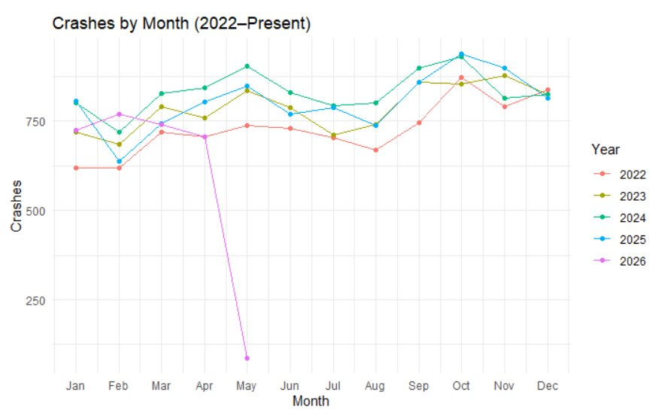
Basic Descriptive Statistics
The datasets contained thousands of roadway related records collected throughout Montgomery County from 2022 to the present.
The traffic crash dataset included variables such as crash severity, weather conditions, timestamps, light conditions, and geographic coordinates. The traffic violation dataset contained demographic information, citation descriptions, stop locations, and timestamps. The non-motorist dataset included injury severity, at fault status, and pedestrian or cyclist involvement.
The traffic violation dataset contained the largest number of records, while the non-motorist dataset contained fewer but more injury focused incidents involving vulnerable road users.
Several variables were used repeatedly throughout the analysis, including:
- Date and time variables
- Injury severity
- At fault status
- Geographic coordinates
- Violation descriptions
Table 1 provides a brief summary of the major datasets used throughout the project.
Dataset | Main Focus | Example Variables
Traffic Crashes | General collision reports | Date, time, weather, severity
Non-Motorist Crashes | Pedestrian and cyclist incidents | Injury severity, fault, location
Traffic Violations | Driver violations and citations | Violation type, location, time
Analyses
Several forms of analysis were performed throughout the project to better understand roadway safety patterns within Montgomery County.
The first major visualization focused on crash trends over time. This line graph showed that crash activity fluctuated throughout the dataset but remained consistently high overall. One of the strongest patterns identified was the increase in crash reports during the September through November period.
Another visualization focused on traffic violations over time. The violations graph showed trends very similar to the crash dataset, particularly during busier traffic periods. The similarities between these patterns suggested that increased roadway activity and traffic density may contribute to both increased violations and increased crash activity.
The non-motorist section included multiple visualizations, including trend graphs, fault comparisons, and injury severity analysis. These visualizations highlighted increased risks faced by pedestrians and cyclists while also showing that non-motorists were sometimes listed at fault in incidents. The injury severity analysis further demonstrated how non-motorist crashes can result in serious injuries because pedestrians and cyclists have less physical protection compared to vehicle occupants.
The GIS heat maps became one of the most important analytical components of the project. Separate heat maps were created for traffic crashes and traffic violations. These maps allowed roadway incidents to be analyzed geographically across Montgomery County.
One of the most interesting findings from the GIS analysis was that crash and violation hotspots appeared more concentrated near intersections and dense traffic areas rather than highways. This suggested that traffic interaction points, turning activity, and congestion may contribute more heavily to crash and violation density than high speed highway driving alone.
The project provided several forms of value through both analysis and visualization. Combining multiple datasets together allowed for broader interpretation of roadway safety patterns instead of examining crashes or violations independently. The visualizations made trends easier to identify and interpret, while the GIS analysis highlighted high risk areas geographically.
The project also demonstrated how data science techniques can be applied to real world public safety issues. Whether individuals are driving, walking, or cycling, everyone depends on safe roadways during daily routines. The findings from this project help identify periods and locations where individuals may need to be more cautious and aware of roadway risks.
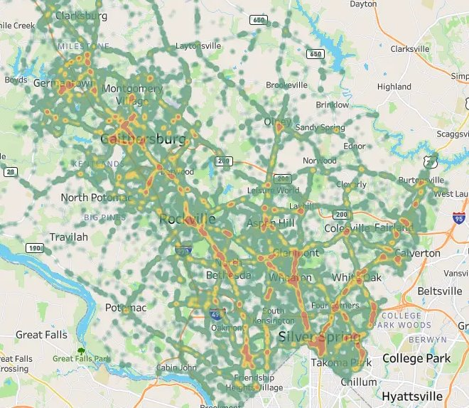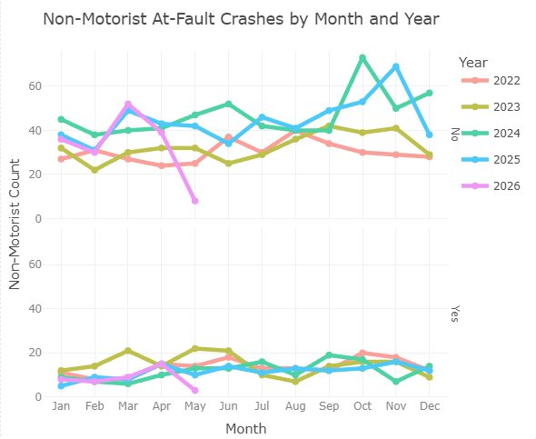
References and Acknowledgements
References
- Data Montgomery Open Data Portal
- Maryland State Police Automated Crash Reporting System (ACRS)
- R Studio
- Tableau Public
- GitHub
Acknowledgements
Special acknowledgement is given to the organizations and law enforcement agencies that collected and maintained the traffic datasets used throughout this project. Thank you Professor Perine for an informative semester along with my classmates forgiving feedback and seeing through the eyes of the audience during this project.​ Thank you to Professor Saidi for showing me the basics of R back in summer 2025 and introducing me to Tableau for GIS mapping.

